

Assessment Cover Page
Student Full Name:
Diego Martinez Fuentes
Student Number:
Sba26210
Module Title:
Strategic Thinking
Assessment Title
CA1: Improving corporate Treasury liquidity management by evaluating alternative reserve assets

Lecturer/Supervisor
Taufique Ahmed
Assessment Due Date
25/10/2026
Date of Submission
25/10/2026
Use of AI Tools
I acknowledge the use of Chat GPT for the purpose of Brainstorming and provided a guidance and structure for perform the CA.
Declaration
By submitting this assessment, I confirm that I have read the CCT policy on academic misconduct and understand the implications of submitting work that is not my own or does not appropriately reference material taken from a third party or other source.
I declare it to be my own work and that all material from third parties has been appropriately referenced.
I further confirm that this work has not previously been submitted for assessment by myself or someone else in CCT College Dublin or any other higher education institution.

Contents
Introduction 1
Problem definition 1
Aim and Objectives. 2
Aim. 2
Objectives 2
Scope 2
Methodology 4
Data collection 4
Data preparation. 4
Machine learning models. 4
Model evaluation 4
Visualization and final report 4
Data sources 5
Expected deliverables 6
Project Timeline 7
Ethical and Legal Considerations 8
References 9
Appendix 10

Introduction
Nowadays, the role of a Chief Financial Officer (CFO) is becoming increasingly complex. Inflation, changing interest rates and economic uncertainty can significantly influence a company's financial position and investment decisions. One of the key responsibilities of a company's finance department is to manage its available funds effectively, ensuring that sufficient liquidity is maintained while seeking opportunities to generate returns.
Corporate treasury management plays an important role in this process. Companies need to maintain sufficient cash reserves to meet their operational expenses and short-term financial obligations. However, holding excessive amounts of cash can have an opportunity cost, particularly during periods of inflation, when its purchasing power may decline over time.
The debate surrounding how Japanese companies use their substantial cash reserves provides an example of this challenge. Decisions about whether to retain cash, invest in financial assets, repurchase shares or distribute dividends can influence a company's financial performance and long-term value.
This project will investigate how data analytics and predictive modelling can support corporate treasury management. By analysing the historical behaviour of selected financial assets, the project will explore whether their future performance can be estimated to help companies make more informed decisions about managing a portion of their treasury reserves while maintaining appropriate liquidity.

Problem definition
Corporate treasury management involves balancing the need to maintain sufficient liquidity with the objective of generating returns from available financial resources. Companies must retain enough cash to meet their short-term obligations, manage unexpected expenses and support daily operations. However, maintaining excessive cash reserves may result in missed investment opportunities and a reduction in purchasing power during periods of inflation.
The challenge is determining how a company can allocate a portion of its available treasury funds to suitable financial assets without compromising its liquidity requirements. This decision can be difficult because financial assets have different levels of risk, liquidity and potential return, while their future performance is uncertain.
This project will investigate whether historical financial data and predictive modelling can help estimate the future performance of selected financial assets. The analysis will explore how these predictions could support comparisons between alternative treasury allocation strategies, considering potential returns, investment risk and liquidity requirements.
The overall objective is to assess whether data-driven analysis can provide useful insights to support corporate treasury management decisions and help companies balance the preservation of liquidity with the potential to generate returns on their available funds.

Aim and Objectives.
The purpose is close the gap of having the cash in simple banks accounts and having it invested in different assets. With this gap we will close also the cost of opportunity to be invested or not.

Aim.
The aim of this project is to investigate how predictive analytics can support corporate treasury management by forecasting the returns of selected financial assets and evaluating their suitability for managing surplus corporate cash. The project will analyse historical financial data, compare the predictive performance of appropriate models, and assess potential investment alternatives in terms of expected returns, risk and liquidity requirements.

Objectives
- Collets historical dataset for the target assets to study. Bitcoin, gold and 10 years treasury bonds.
- Identify patterns, volatility of the given assets to predict the future return.
- Create a reliable, predicted forecasting model to estimated future return based in historical data.
- Compare the selected assets based on their predicted returns, historical risk characteristics and liquidity considerations.
- Evaluate the outputs based in the company profile
- Present and visualist the findings

Scope
Included
This project will analyse historical closing-price data for three assets: Bitcoin, gold, and US 10-year Treasury bonds (US10yr). The selected datasets cover the following periods:
- Bitcoin: 2 February 2012 – 17 October 2026.
- Gold: 4 January 2000 – 16 October 2026.
- US 10-year Treasury bonds (US10yr): 4 January 2000 – 16 October 2026.
The datasets cover different time periods because the assets have different historical data availability. Bitcoin is a relatively new asset and therefore has a shorter historical record than gold and US 10-year Treasury bonds. Consequently, the analysis of gold and US10yr will begin in January 2000 and extend to October 2026, while Bitcoin analysis will cover the period from February 2012 to October 2026.
The selected time frames provide an opportunity to examine asset-price behaviour across different economic conditions and periods of financial instability. The historical data includes several significant events, such as the 2008 global financial crisis, the European sovereign debt crisis around 2010–2012, and the COVID-19 pandemic in 2020. These events provide useful historical contexts for investigating how the prices of the selected assets behaved during periods of economic uncertainty.

Methodology

Data collection
This project will use historical daily closing prices and trading volume data for three assets: Bitcoin, gold, and US 10-year Treasury bonds. The data for gold and US 10-year Treasury bonds will cover the period from 2000 to 2026, while the Bitcoin dataset will cover the period from 2012 to 2026, reflecting the different historical data availability of each asset.
The data will be sourced from Investing.com and downloaded in CSV format. These historical financial data are publicly accessible through financial websites and will provide the foundation for the project's data analysis and machine learning modelling.
At this stage, the project will use three CSV files, each containing the historical data for one of the selected assets. These files will subsequently be prepared and analysed to identify patterns and assess the potential relationships between the assets.

Data preparation.
The collected data will be cleaned and prepared to ensure that it is suitable for analysis and machine learning modelling. The main tasks will include checking for missing observations, identifying potential outliers, calculating historical returns, and examining correlations between the selected assets.
The data preparation process will also ensure that the datasets are consistent and suitable for use in the subsequent analytical stages. Particular attention will be given to the available variables and the quality of the data used to train and evaluate the machine learning models.
Exploratory Data Analysis.
We will examine the historical returns, volatility and the correlation between assets

Machine learning models.
Mainly Decision Tree and Random Forest. We will be open to pivot among the models, the first idea is forecasting studies.

Model evaluation
Metrics:
- Maximum drawdown
- Accuracy
- Volatility

Visualization and final report
- Reporting and explanation

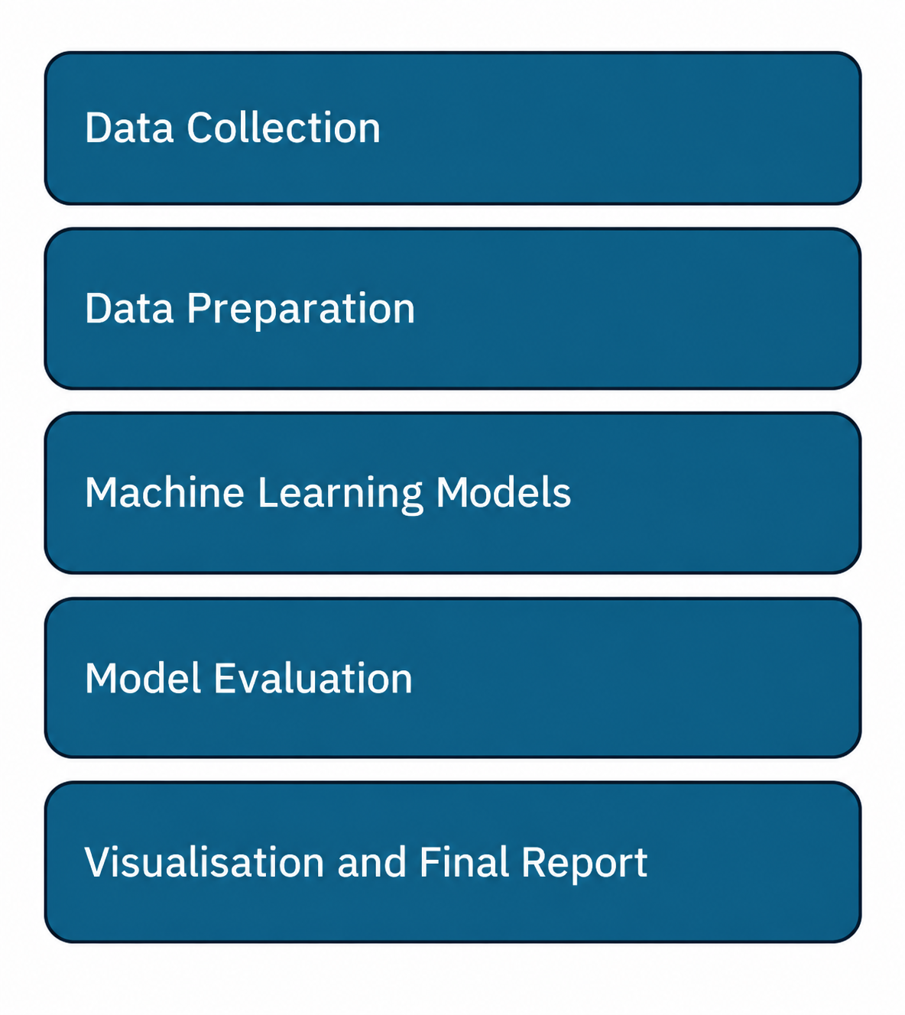

Data sources
The primary data source for this project is Investing.com. This website was selected because it provides publicly accessible financial market information and is a platform I am already familiar with through my daily work.
Although Investing.com is the main source for the selected datasets, similar historical financial data may also be available from other financial websites. Therefore, alternative sources could be considered if additional data is required during the project.
The historical data has been downloaded in CSV format for Bitcoin, gold, and US 10-year Treasury bonds. As the project progresses, the dataset may be expanded to include additional assets, provided that the data is accessible, relevant to the research objectives, and suitable for comparative analysis.

Expected deliverables
Data Collection
Download the historical data for the three selected assets: Bitcoin, gold, and US 10-year Treasury bonds. The data will be stored in three separate CSV files, one for each asset.
Data Preparation
Use Python to clean and prepare the datasets, ensuring that they are suitable for analysis and machine learning modelling. This process will include checking for missing observations, identifying errors, and addressing any data quality issues.
Machine Learning Models
Develop and train suitable machine learning models using the prepared datasets to predict future asset-price movements or returns. Evaluate the models using appropriate performance metrics, such as accuracy, precision, and other relevant measures, depending on the modelling approach selected.
Final Report
Produce a comprehensive final report documenting the business problem, the proposed methodology, the data preparation process, the machine learning models developed, and the results obtained. The report will present the main findings, discuss the limitations of the analysis, and provide conclusions based on the results.

Project Timeline
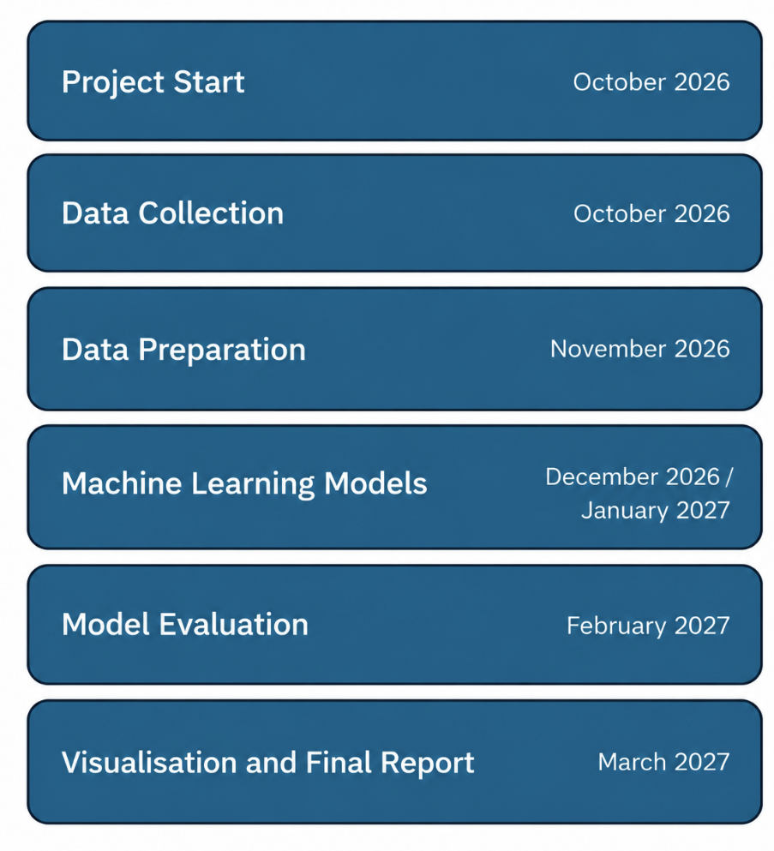

Ethical and Legal Considerations
Throughout the project, publicly available financial data relating to three different assets—Bitcoin, gold, and US 10-year Treasury bonds—has been used. The selected datasets contain historical financial market information and do not include personal, sensitive, or confidential information. Therefore, the project is not expected to raise significant data privacy concerns under the General Data Protection Regulation (GDPR).
The collected data will be used exclusively for research and academic purposes. Any external data sources and supporting materials used throughout the project will be appropriately acknowledged and referenced in accordance with Harvard referencing guidelines.
Regarding the use of artificial intelligence (AI) tools, the project has followed CCT College Dublin's guidance on responsible AI use. The AI declaration has been completed in accordance with the college's requirements, documenting the use of AI tools throughout the project.

References
(https://www.investing.com/, 2026)

Appendix
I have used CHAT GPT for grammar correction and text structure. This is the prompt used and I have been pasting the text created for me.


I made also a check list to do a straightforward tasks once I made the project to fix everything.


For the futures deliveries I expect increase the use of IA always from the point of view of assistance, not for doing my duties.

